● What are ACID properties and Explain Transactions in Hive.

**ACID:**

ACID stands for Atomicity, Consistency, Isolation, and Durability.

Atomicity means, a transaction should complete successfully or else it should fail completely i.e. it should not be left partially. Consistency ensures that any transaction will bring the database from one valid state to another state. Isolation states that every transaction should be independent of each other i.e. one transaction should not affect another. And Durability states that if a transaction is completed, it should be preserved in the database even if the machine state is lost or a system failure might occur.

These ACID properties are essential for a transaction and every transaction should ensure that these properties are met.

**Transactions in Hive:**

Transactions in Hive are introduced in Hive 0.13, but they only partially fulfill the ACID properties like atomicity, consistency, durability, at the partition level. Here, Isolation can be provided by turning on one of the locking mechanisms available with zookeeper or in memory.

But in Hive 0.14, new API’s have been added to completely fulfill the ACID properties while performing any transaction.

Transactions are provided at the row-level in Hive 0.14. The different row-level transactions available in Hive 0.14 are as follows:

1. Insert
2. Delete
3. Update

There are numerous limitations with the present transactions available in Hive 0.14. ORC is the file format supported by Hive transaction. It is now essential to have ORC file format for performing transactions in Hive. The table needs to be bucketed in order to support transactions.

● Hive Transaction Operations.

Create a table for the transactions, for transactions we need to bucket the table and store it in orc file format as well as the tblproperties(‘transactional’=’true’) has to be set.

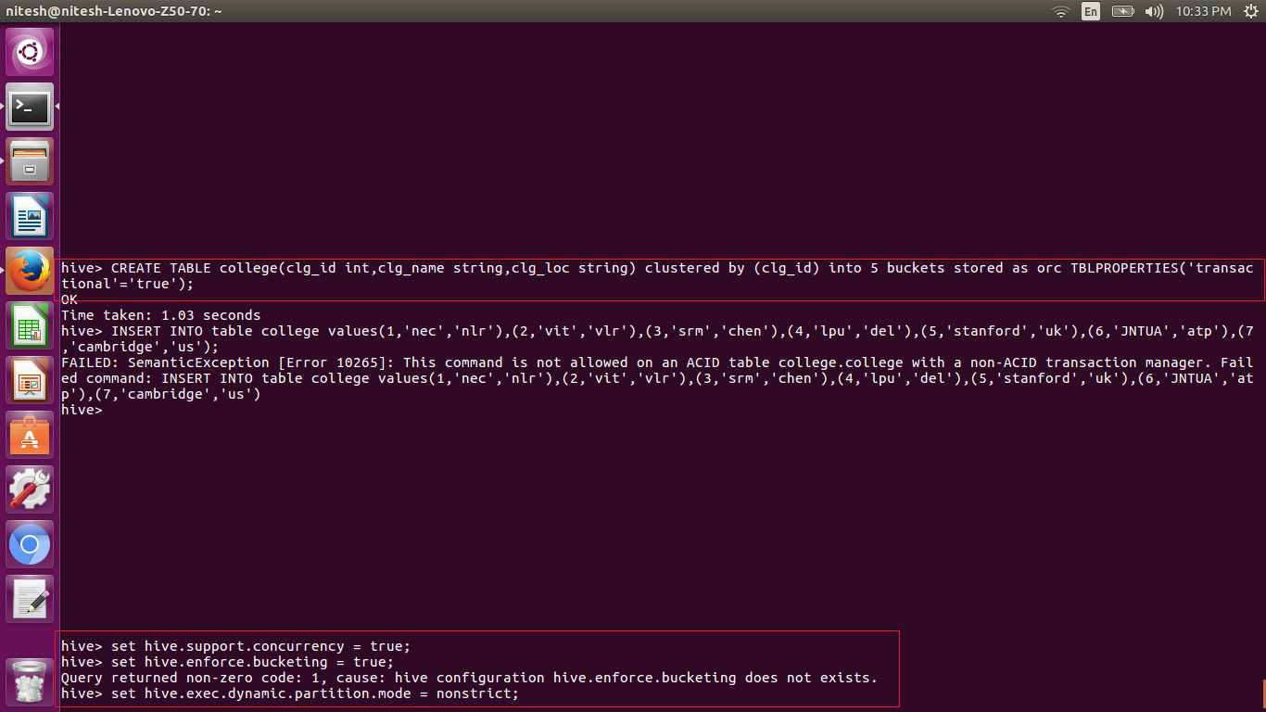

Here we need to set the properties before the transactions are done. If it is not set then only update and the insert will work. But not the delete command will work.

Here insert into command is shown in below screenshot:

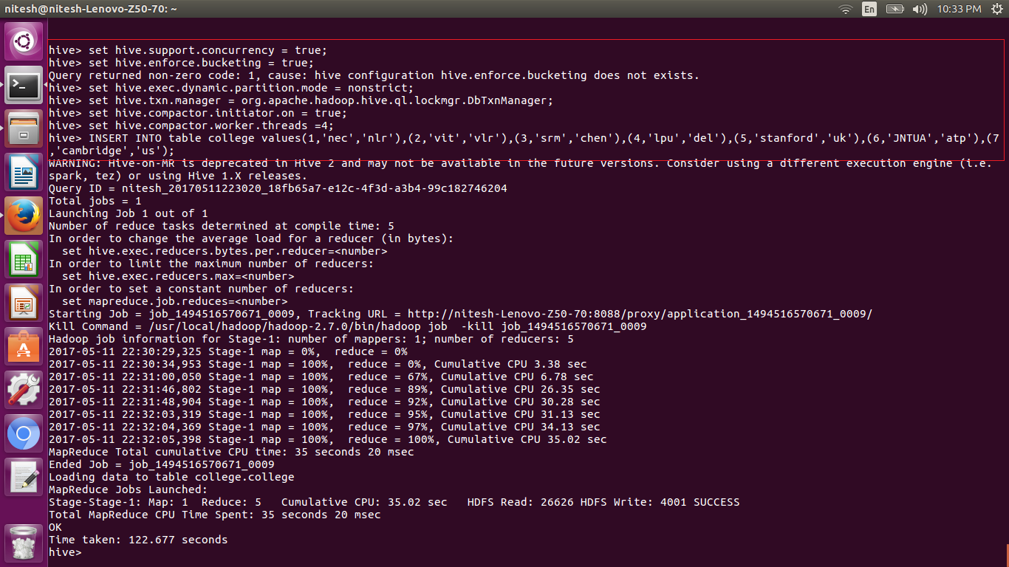

Here we have set the college name using update command

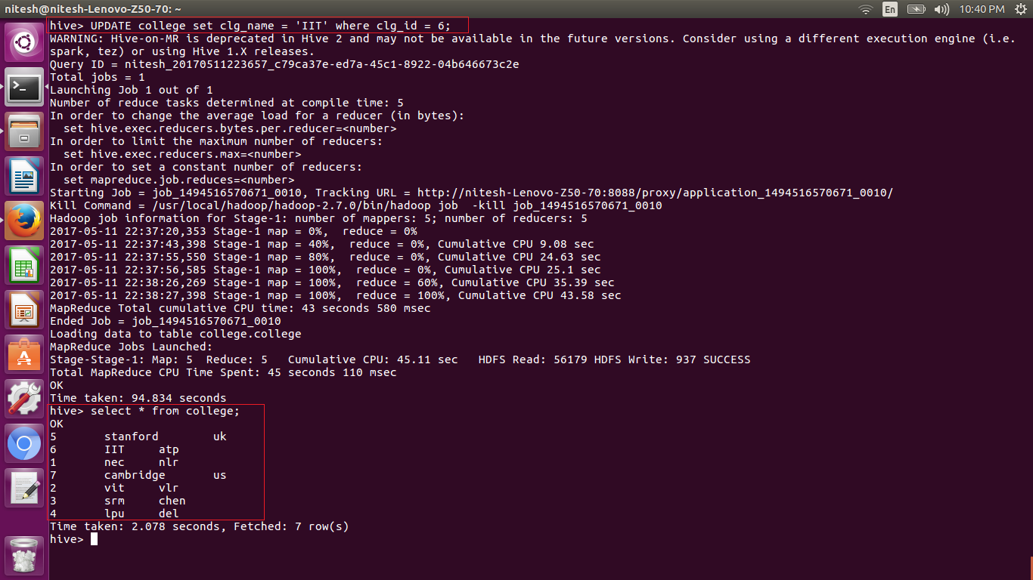

The delete command to delete the row is shown below:

